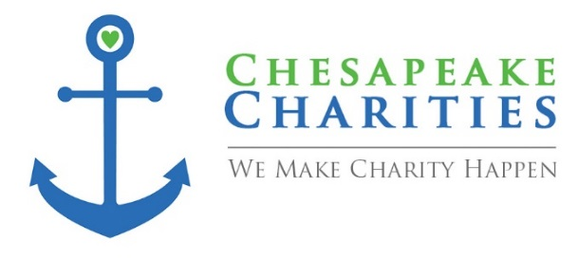
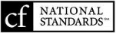

HOW TO SUGGEST A GRANT
Chesapeake Charities, a community foundation, gives our partners personalized service to meet their goals for giving. Grants are made for charitable or educational activities as defined by Section 501(c)(3) of the IRS Code. In addition, you can be certain that we carefully review every grantee. We study their programs in relation to its goals and objectives and review financial information to insure that grants are well placed. In considering your grantmaking, keep in mind that Chesapeake Charities’ services include local expertise and information on area needs and nonprofit organizations.
Grants for general support or for a specific program or activity may be recommended. For efficient and effective grantmaking, advisors are encouraged to allocate a portion of their grant funds to support the foundation’s community grants program. There are two convenient ways to issue grants through this program; (1) select an agency from the list of designated funds held by Chesapeake Charities or (2) allocate funds to the General Fund so the Board of Directors may determine how best to distribute grant funds.

RECOMMENDATION/REQUEST
Fund Name:

Purpose of Request:

Check made out to:

Amount: |  | $
Date:

Are Receipts Attached: |  | ☐YES ☐NO  If no, indicate the date receipts will be provided:
Additional Comments:
Note: Checks should be requested by the close of business on Monday and will be available
one week later on Tuesday.
By signing below, I certify that this request is for the stated charitable purpose of the fund.
Name: |  |  |  | ________________________________________________  Signature
 | Staff Use Only:
 | Reviewed by Foundation Staff on:
 | Verified Fund Advisor |  |  |  | Date
 | Circle One: |  |  |  | Funds Available: | Yes No
 | Recommend  Approve |  | Recommend Deny
 |  |  |  |  | Signature

101 Log Canoe Circle, Suite O Stevensville, MD 21666 (410) 643-4020 Fax (410) 643-4021 info@chesapeakecharities.org

